**CIND 119: Introduction to Big Data Analytics**

**Assignment 2**

**Submitted by:**

**Marco Muto**

create database sample;

use database sample;

create table test_data (

class varchar(3),

age int,

menopause varchar(7),

tumor_size int,

node_caps varchar(3),

deg_malig int,

breast varchar(5),

breast_quad varchar(10),

irradiat varchar(3)

);

select * from test_data;

insert into test_data (class, age,menopause,tumor_size,node_caps,deg_malig,breast,breast_quad,irradiat)

values('NO',35,'premeno',31,'no',3,'left','left_low','no');

insert into test_data (class, age,menopause,tumor_size,node_caps,deg_malig,breast,breast_quad,irradiat)

values('NO',42,'premeno',22,'no',2,'right','right_up','no');

insert into test_data (class, age,menopause,tumor_size,node_caps,deg_malig,breast,breast_quad,irradiat)

values('NO',30,'premeno',23,'no',2,'left','left_low','no');

insert into test_data (class, age,menopause,tumor_size,node_caps,deg_malig,breast,breast_quad,irradiat)

values('NO',61,'ge40',16,'no',2,'right','left_up','no');

insert into test_data (class, age,menopause,tumor_size,node_caps,deg_malig,breast,breast_quad,irradiat)

values('NO',45,'premeno',2,'no',2,'right','right_low','no');

insert into test_data (class, age,menopause,tumor_size,node_caps,deg_malig,breast,breast_quad,irradiat)

values('NO',64,'ge40',17,'no',2,'left','left_low','no');

insert into test_data (class, age,menopause,tumor_size,node_caps,deg_malig,breast,breast_quad,irradiat)

values('NO',52,'premeno',27,'no',2,'left','left_low','no');

insert into test_data (class, age,menopause,tumor_size,node_caps,deg_malig,breast,breast_quad,irradiat)

values('NO',67,'ge40',21,'no',1,'left','left_low','no');

insert into test_data (class, age,menopause,tumor_size,node_caps,deg_malig,breast,breast_quad,irradiat)

values('YES',41,'premeno',52,'no',2,'left','left_low','no');

insert into test_data (class, age,menopause,tumor_size,node_caps,deg_malig,breast,breast_quad,irradiat)

values('YES',43,'premeno',22,'no',2,'right','left_up','no');

insert into test_data (class, age,menopause,tumor_size,node_caps,deg_malig,breast,breast_quad,irradiat)

values('YES',41,'premeno',1,'no',3,'left','central','no');

insert into test_data (class, age,menopause,tumor_size,node_caps,deg_malig,breast,breast_quad,irradiat)

values('YES',44,'get40',27,'no',2,'left','left_low','no');

insert into test_data (class, age,menopause,tumor_size,node_caps,deg_malig,breast,breast_quad,irradiat)

values('YES',61,'it40',14,'no',1,'left','right_up','no');

insert into test_data (class, age,menopause,tumor_size,node_caps,deg_malig,breast,breast_quad,irradiat)

values('YES',55,'get40',26,'no',3,'left','right_up','no');

insert into test_data (class, age,menopause,tumor_size,node_caps,deg_malig,breast,breast_quad,irradiat)

values('YES',44,'premeno',32,'no',3,'left','left_up','no');

/*test*/

select * from test_data;

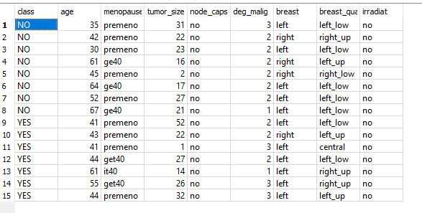

/*3a*/

select *

from test_data

where menopause = 'ge40';

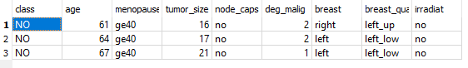

/*3b*/

select *

from test_data

where age < 41;



/*3c*/

select *

from test_data

where age < 41

and menopause = 'ge40';

/*yields no results*/



/*3d*/

select AVG(age) as "Average age"

from test_data;



/*3e*/

select AVG(age) as "Average age where deg_malig=3"

from test_data

where deg_malig=3;

